American Chemical Society’s
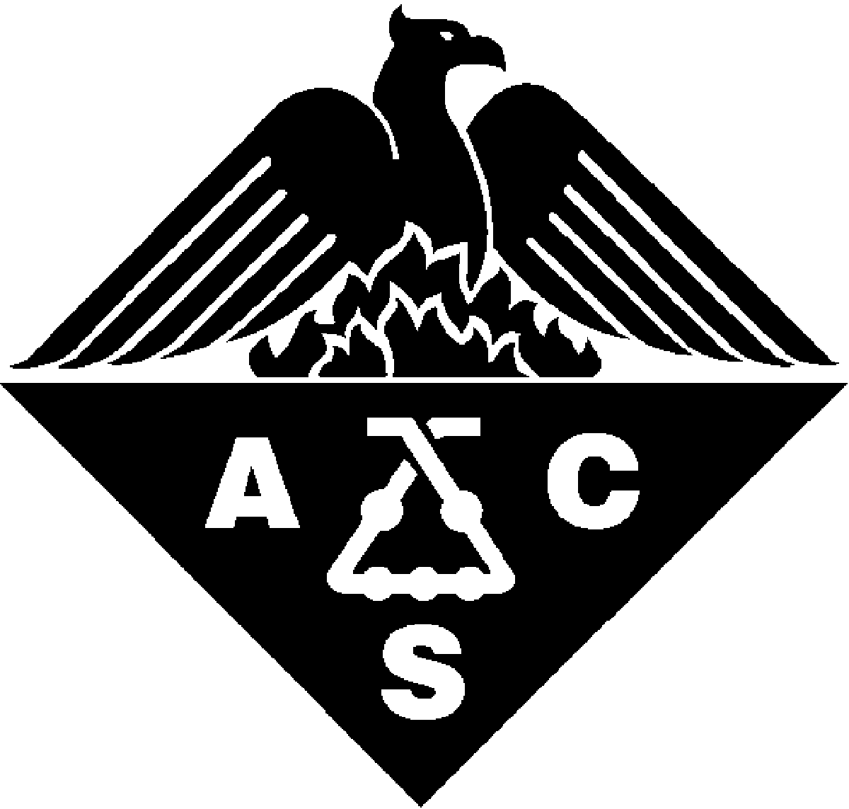
New York Section, Inc.

WILLIAM H. NICHOLS MEDAL AWARD

Nomination Form

Deadline: May 31, 2024

Submittal process: Submit electronic version of this completed form, CV, and up to three seconding letters via email to Nichols_Medal@newyorkacs.org

Date:

NOMINEE INFORMATION
First Name:
Middle Initial:
Last Name:
Company or Institutional Affiliation:
Present Position (Exact Title):
Address:
City:
State:
Zip:
Country:
Business Telephone:
Home Telephone:
Fax:
Email:
Website:
Date of Birth:
Has this nomination been discussed with the nominee? Yes No
SUGGESTED CITATION (60 characters or less)
In the space below, paste or type a suggested citation. Identification of a specific achievement is often more effective than a generic statement of excellence.

NOMINATOR INFORMATION
First Name:
Middle Initial:
Last Name:
Company or Institutional Affiliation:
Present Position (Exact Title):
Address:
City:
State:
Zip:
Country:
Telephone:
Fax:
Email:

Recommendation
In the space below, paste or type a narrative summary of 1,000 words or less. A separate attachment may be substituted. Include the following in your narrative:
- Evaluate the nominee’s accomplishments and a specific identification of the work to be recognized.
- Highlight contributions made in the past 5 years.
- Comment on broader scholarly contributions, including education and service.

PUBLICATIONS AND PATENTS
In the space below, paste the nominee’s publications and patents list. A separate attachment may be substituted.

BIOGRAPHICAL SKETCH
In the space below, paste a brief biography of the nominee. In addition, please submit a current CV.

Support FORMS

Support forms are being requested from the following individuals (please limit to a maximum of three).

Name, Affiliation, Telephone, Email

1.

2.

3.

Deadline: May 31, 2024

