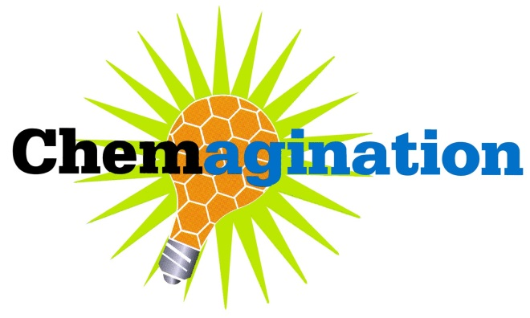
Intent to Participate Form

Please print or type requested information and return this form before February 7, 2020
School Contact/
Advisor Name: Title:

E-mail address: Home Phone (optional): ( ) –

School Name:

School Address: Street

City State Zip code

Preferred mailing address if different from school address:

School Phone: ( ) – School Fax: ( ) –

Is the e-mail address written above the best way to reach you with important information? (Check one)

Yes No If no, please suggest an alternative:

If we need to call, what are the best times to reach you?

Which categories does your school intend to enter? (Please indicate the number of entries from each category)

Alternative Energy Sources Medicine/ Healthcare

Environment New Materials

_______ Protein and Protein Engineering

To aid our planning, please indicate the total number of students and total number of teams:

Total number of teams ___ Total number of students

By submitting this form, I am committing my school/students to entering the Chemagination contest.
I will: notify Dr. Muth or Dr. Yoganathan immediately if there is any change in the status of our participation or our entries.

Signature: Date:

Send or fax to:
Dr. Aaron Muth, St. John’s University, Department of Pharmaceutical Sciences,
8000 Utopia Parkway, Jamaica, NY 11439 Fax: 718-990-1877 or E-mail: mutha@stjohns.edu

Questions? Call Dr. Aaron Muth at 718-990-6678 or E-mail: mutha@stjohns.edu
Dr. Sabesan Yoganathan at 718-990-5215 or E-mail: yoganats@stjohns.edu

